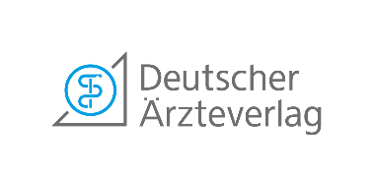

Granting of rights
For authors of dental-scientific manuscripts
Manuscript: [ ]
Corresponding author: [ ]
Other authors: [ ]
In addition to § 38 UrhG, as corresponding author I transfer to Deutscher Ärzteverlag the exclusive copyrighted rights of use to the afore mentioned work, in particular the right to the work, edited or unprocessed, in whole or in part, to reproduce, distribute and publish, or to make available to the public, without time, space and content restrictions, in all media. The transfer of the comprehensive exploitation rights takes place in particular for the purpose of the comprehensive unrestricted evaluation of the printing and ancillary printing rights and thus also includes the right to pre-print and reprint, including the corresponding online rights, as part of the print products published by Deutscher Ärzteverlag, as well as the Internet platforms operated by Deutscher Ärzteverlag.
Deutscher Ärzteverlag is entitled, but not obliged, to use the work. Only the Deutscher Ärzteverlag decides on the manner and scope of the exploitation of the rights granted or the work. Furthermore, Deutscher Ärzteverlag is entitled, but not obliged, to use the names of contractual partners within the scope of the rights transferred under this agreement or to have them used by third parties. Deutscher Ärzteverlag may transfer all or part of the rights and powers granted by this agreement to third parties as simple or exclusive rights or permit such transfer to third parties.
I guarantee that at the time of the provision of the contractual service I have the aforementioned rights without restriction, that I can dispose of them, that I have not otherwise disposed of them and that I will not dispose of them; nor do any other rights of third parties or contractual relationships with third parties conflict with the performance of the contract. In this respect, I indemnify Deutscher Ärzteverlag against all third-party claims asserted in connection with the contractual services and rights to the full extent, including any costs of reasonable legal defence. Further claims for damages by Deutscher Ärzteverlag remain unaffected
Please send the completed declaration by e-mail, post or fax to:

Deutscher Ärzteverlag GmbH, Ms. Irmingard Dey (DZZ), Dieselstr. 2, 50859 Köln
(Fax: 0 22 34 70 11 6-242), Mail address: Dey@aerzteverlag.de
[ ] | [ ]
Place and date | Name/signature
 | (signature not required for mail dispatch)

